Southern Chapter tours the new Brown County Music Center in Nashville Indiana
On February 27th 23 members of the Southern Chapter toured the new Brown County Music Center after an informative talk on edible mushroom species by Brian Hunt.
Brian Hunt discussed some of the many variations of mushrooms that can be found in Indiana during the colder months of the year. Photos were provided of many varieties growing and explanations on some of the features, like gills, pores, etc. were discussed. Caution was abundant as to eating any unidentified mushrooms. Brian is a certified mushroom expert and can validate mushrooms for restaurants wishing to use wild mushrooms. He can be contacted at browncountymushrooms@yahoo.com
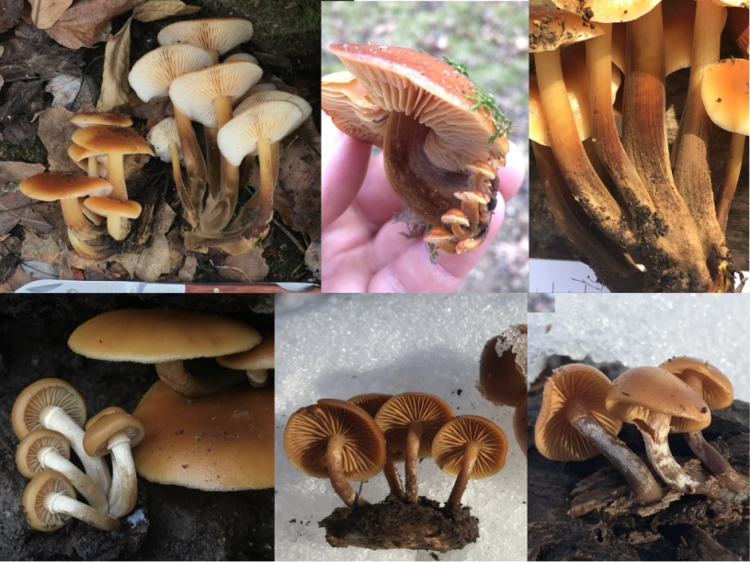
The group next went to the Brown County Music Center, opened in August 2019 for a behind-the-scenes tour with Andrea Swift Hanlon, Customer Services Director. Andrea explained the construction and security issues, let the group sit in the front row while she took questions and answers and brought the group backstage. We saw the areas where performers relax, eat, shower and prepare for their performance.
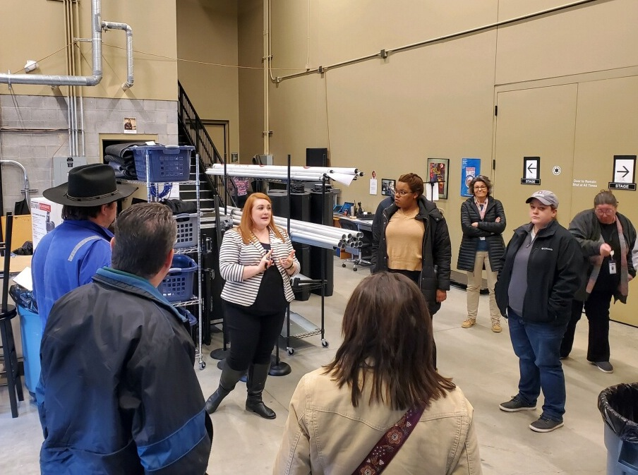
Backstage with andrea, Mary Wilson, (IU Intern for Brown County Health Dept) watching from her left
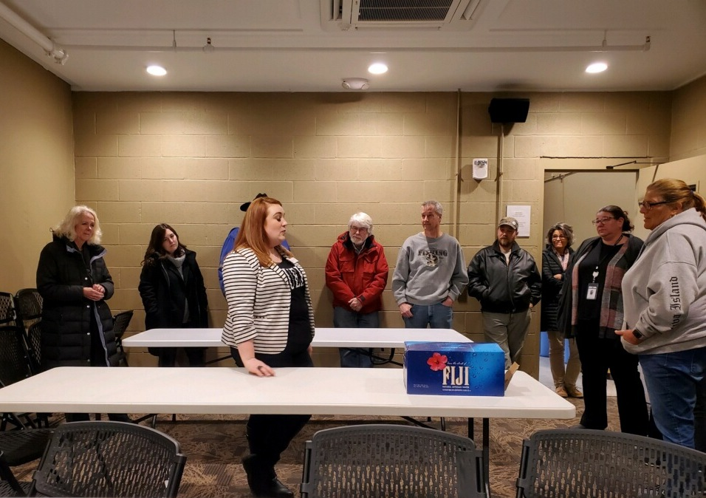
The Green Room, where performers are provided with food and drink of their choice according to their contract with BCMC
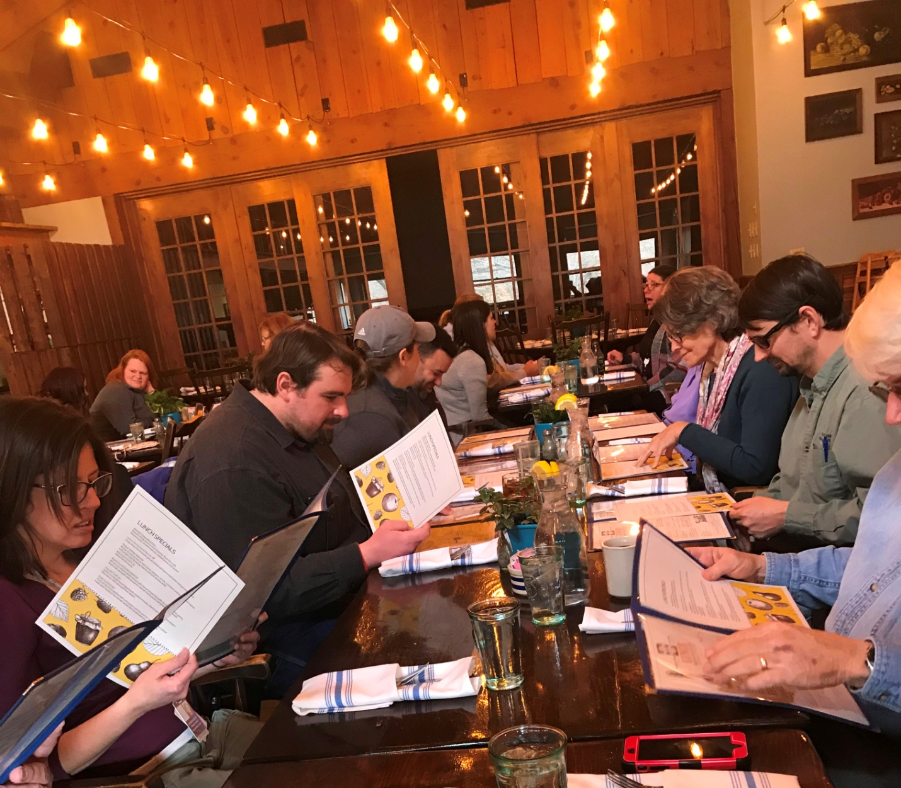
THe Chapter then descended upon the Brown County Inn for a delicious lunch.
Jennifer Heller, President Southern Chapter, VP IEHA

